MicrosoftWord – Labels Instructions
- Thermal Transfer Foil Label - HCL #17295

CREATING A LABEL DEFINITION
- Begin with a new, blank document in Microsoft Word.

- Select Tools from the main menu bar. Then select Envelopes and Labels from the drop-down menu.

- The Envelopes and Labels dialogue box will appear. Select the Labels tab:

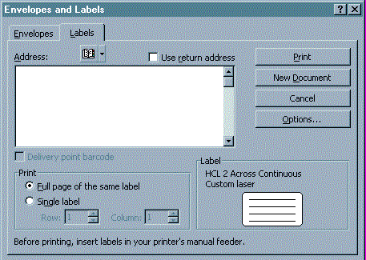

- Select the Options button and the Label Options dialogue box will appear:

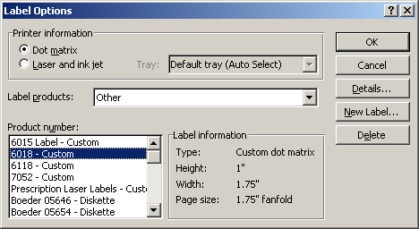

- Select the Laser button (circled above), under Printer information.

- Select Other (see arrow above) in the Label products drop-down menu.

- Select the New Label button and the New Custom Laser dialogue box will appear:

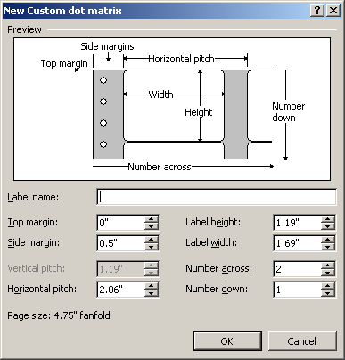

- Fill out the fields in the New Custom Laser screen with the below parameters:

Label Name: 17295 – High Barrier Thermal Labels
Top Margin: .0625” Label Height: 1”
Side Margin: .078” Label Width: 1.72”
Vertical Pitch: [blank] Number Across: 1
Horizontal Pitch: [blank] Number Down: 9
Page size: 8 ½ x 11 Letter

- Select the OK button to save the settings and exit the New Custom Laser window.
- Select OK from the Label Options window.
- From the Envelopes and Labels window, you can either continue with printing the labels by proceeding to step 3 below or close the window by clicking Cancel.

PRINTING LABELS USING YOUR CUSTOM DEFINED LABEL DEFINITION
- After you have set up your label definition, open a new blank page in Word.

- Click on Tools > Envelopes and Labels. The Envelopes and Labels dialog box will appear:
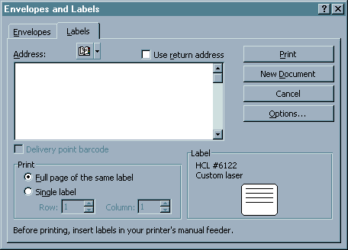

- Type the text in the Address window just as you want it to appear on the labels, such as:

Health Care Logistics

450 Town Street
Circleville, OH 43113

You can adjust font attributes by hi-lighting the text, right-click with your mouse and selecting Font from the pop-up menu.

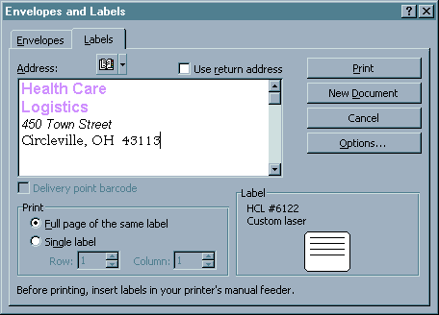

- Click on the Options button. The Label Options dialog box will appear.

- Select Laser (see arrow above) under Printer Information. In the Product Number (circled above) field, select the label definition that you just created or the one that you want to use. Click on OK.

- This will take you back to the Envelopes and Labels dialog box.

  - To print a full page of the same label, select this option under Print and then click on the New Document button. This will take you to a new document window that contains a full page of the labels with the text you just typed. You can edit the text and change font attributes directly on this page.
  - To print a single label, select this option under Print. Specify the Row and Column of the label you want to print and then click on Print.
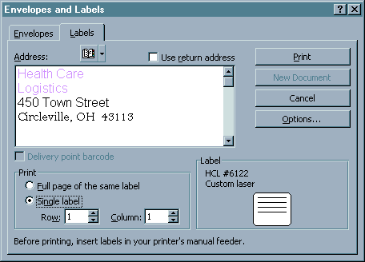

- Your labels are now ready to be printed. Select File > Print and the Print dialog box will appear:

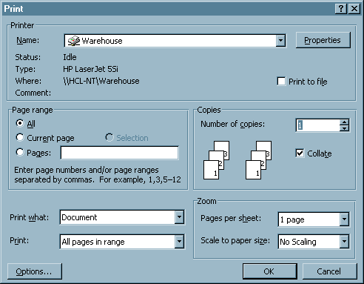

- From the Print dialog box, you can select the printer where you want to print the labels to and the number of copies (pages) you want to print.

- Click OK to print the labels.

- You can now save the document, if you desire, so you can retrieve it later for reprinting. Click on File > Save As and the Save As dialog box will appear:

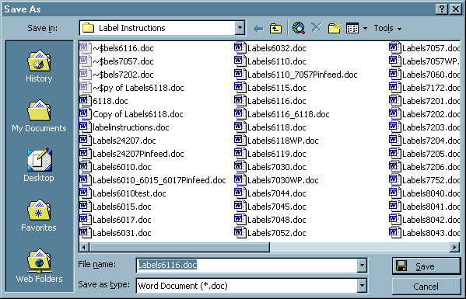

- Select the Save In location from the drop down menu.

- Type in the name you want to save the file to in the File Name box.

- Click on Save.



Health Care Logistics, Inc.
Phone: 800 848 1633 · Fax: 800 447 2923
Email: hcl@healthcarelogistics.com
Web: www.healthcarelogistics.com

