MicrosoftWord – Labels Instructions
- Extra High Barrier Laser Foil Label - HCL #6027

CREATING A LABEL DEFINITION
- Begin with a new, blank document in Microsoft Word.

- Select Tools from the main menu bar. Then select Envelopes and Labels from the drop-down menu.

- The Envelopes and Labels dialogue box will appear. Select the Labels tab:

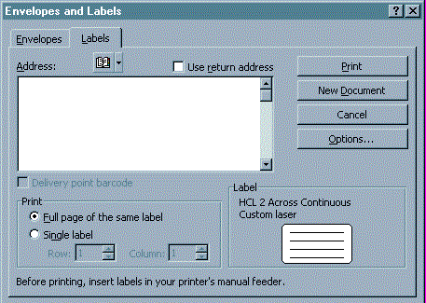

- Select the Options button and the Label Options dialogue box will appear:

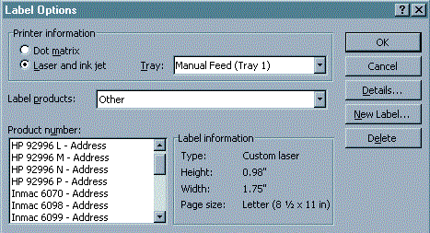

- Select the Laser and ink jet button (circled above), under Printer information.

- Select the printer Tray (in the rectangle above) that the labels will print from. Please note that this setting will vary depending on the type of printer you are using.

- Select Other (see arrow above) in the Label products drop-down menu.

- Select the New Label button and the New Custom Laser dialogue box will appear:

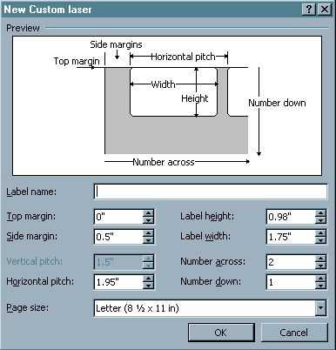

- Fill out the fields in the New Custom Laser screen with the below parameters:

Label Name: Laser Foil Label - #6027
Top Margin: 1.5” Label Height: 1.188”
Side Margin: .563” Label Width: 1.188”
Vertical Pitch: 0” Number Across: 5
Horizontal Pitch: .375” Number Down: 7
Page size: Letter (8 ½ x 11 in)

- Select the OK button to save the settings and exit the New Custom Laser window.
- Select OK from the Label Options window.
- From the Envelopes and Labels window, you can either continue with printing the labels by proceeding to step 3 below or close the window by clicking Cancel.

PRINTING LABELS USING YOUR CUSTOM DEFINED LABEL DEFINITION
- After you have set up your label definition, open a new blank page in Word.

- Click on Tools > Envelopes and Labels. The Envelopes and Labels dialog box will appear:
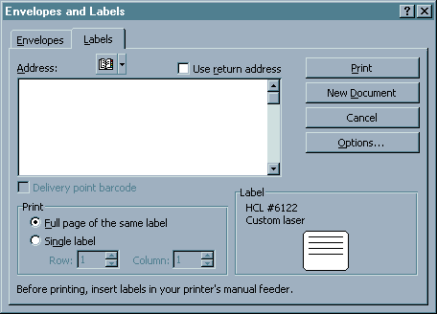

- Type the text in the Address window just as you want it to appear on the labels, such as:

Health Care Logistics

450 Town Street
Circleville, OH 43113

You can adjust font attributes by hi-lighting the text, right-click with your mouse and selecting Font from the pop-up menu.

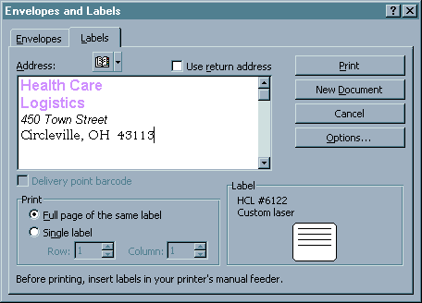

- Click on the Options button. The Label Options dialog box will appear.

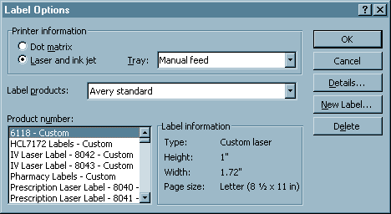

- From the Product Number (circled above) field, select the label definition that you just created or the one that you want to use. Click on OK.

- This will take you back to the Envelopes and Labels dialog box.

  - To print a full page of the same label, select this option under Print and then click on the New Document button. This will take you to a new document window that contains a full page of the labels with the text you just typed. You can edit the text and change font attributes directly on this page.
  - To print a single label, select this option under Print. Specify the Row and Column of the label you want to print and then click on Print.
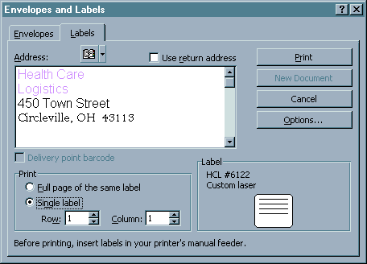

- Your labels are now ready to be printed. Select File > Print and the Print dialog box will appear:

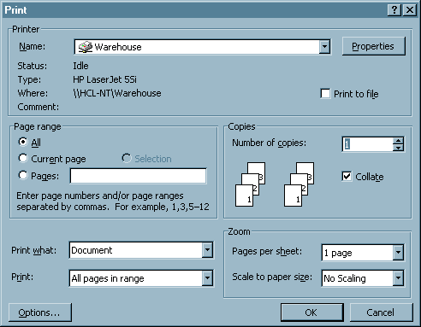

- From the Print dialog box, you can select the printer where you want to print the labels to and the number of copies (pages) you want to print.

- Click OK to print the labels.

- You can now save the document, if you desire, so you can retrieve it later for reprinting. Click on File > Save As and the Save As dialog box will appear:

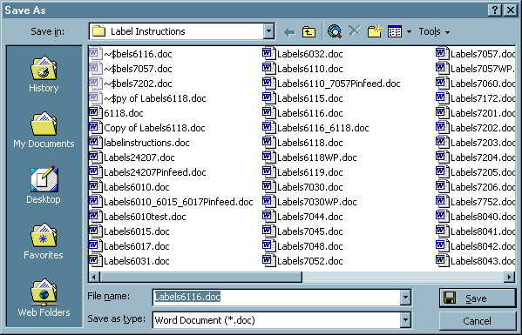

- Select the Save In location from the drop down menu.

- Type in the name you want to save the file to in the File Name box.

- Click on Save.



